1. set up a python envirionment
   1. Python3 -m venv myvenv
2. install wireshark if not there
   1. sudo apt install wireshark
   2. sudo apt install tshark
3. add wireshark to the main group   
    a. sudo usermod -aG wireshark $USER

b. restart the VM

1. check if wireshark set up properly
   1. tshark -D

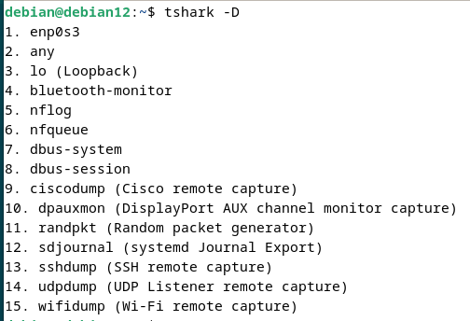

If you can see enps3 or wlan0 then it means its set up peoperly

1. activate myvenv (python environment)
   1. source myvenv/bin/activate
2. locate to the project file and run following command to install necessary libraries
   1. pip install -r requirements.txt
3. now everything has been set up to run the application just do
   1. python run.py